Scrappy Market: Agentic AI System
Design Document
Version 1.0

- Introduction
  - Purpose
The purpose of this document is to outline the system design, core components, and interaction flow between various agents. It provides a detailed architectural overview of how system is structured, how responsibilities are distributed across individual agents, and how data and control flow through the system during execution. This document is intended to serve as a technical reference for understanding the overall behavior of the system.

  - Scope
The document describes the end-to-end workflow of the system and explains how multiple technologies work together to enable the input and output generation. The scope of this document includes the interaction between the reasoning engine, AI agent framework, relational database and a user interface.
  - Technology stack
- Programming Language: Python
- AI Agent Framework: LangGraph
- Reasoning Engine: Ollama 3.1
- Database: MySQL
- User Interface: Streamlit

- System Design
  - Architecture
The system is designed as a modular, agent-orchestrated platform that converts a natural language into a structured investigation workflow. The architecture follows a layered approach where a user interface layer collects the input and displays the outcome of the investigation, an orchestration layers coordinates multiple specialized agents, and a data layer provides access to the relational database system. On top of that, a large language model (LLM) is used as the reasoning engine which empowers the individual agents with their desired capabilities. The design also supports expansion to the platform as needed such as additional agents, new database tables or UI updates.
  - Agents
The agent represents the system’s functional intelligence and is responsible for performing a specific set of tasks within the overall workflow. Each agent is designed with a scope and clear responsibility which allows the system to interpret request into smaller manageable actions. By limiting each agent to a focused role, the system improves the modularity, scalability and the transparency of the intermediate reasoning steps.
The following is the description of the agents used in this application
    - Intent Agent
This agent is responsible for interpreting the user natural input and identifying the intention of the request. The agent extracts key information such as the type of investigation being requested, relevant business metrics, table names, and time range. This output of the agent establishes the foundation for the investigation by converting the natural and unstructured information into a structured representation which is then used by the downstream agents.

    - Planner Agent
The planner agent consists of a logical step required to answer the user’s question. It uses the structured output produced by the intent agent to generate an investigation plan. By explicitly outlining investigation steps, the planner agent improves explainability and ensures that the reasoning process remains transparent and traceable throughout the execution.
    - Query Builder Agent
The query builder agent translates the investigation plan into a database queries. This agent maps the investigation steps into appropriate database tables using its relationship. Based on this mapping, the agent generates the structured SQL queries that align with the investigation requirements.
    - Data Retrieval Agent
The data retrieval agent is responsible for executing the generated SQL queries against the database and return the results in a structured format.
    - Summary Agent
The summary agent summarizes all the key finding, highlights the anomalies and provides the recommendation if applicable. This agent synthesizes the outputs from all the previous agents and produces a human readable explanation of the investigation.
  - Reasoning Engine
The reasoning engine is a core architectural component responsible for interpreting the semantic understanding, decision making and reasoning across the system. The reasoning engine is implemented using a Large Language Model (LLM), which is invoked by individual agents to interpret the input and generate the structured output.
  - Agent Interaction Diagram
    - Agent Interaction
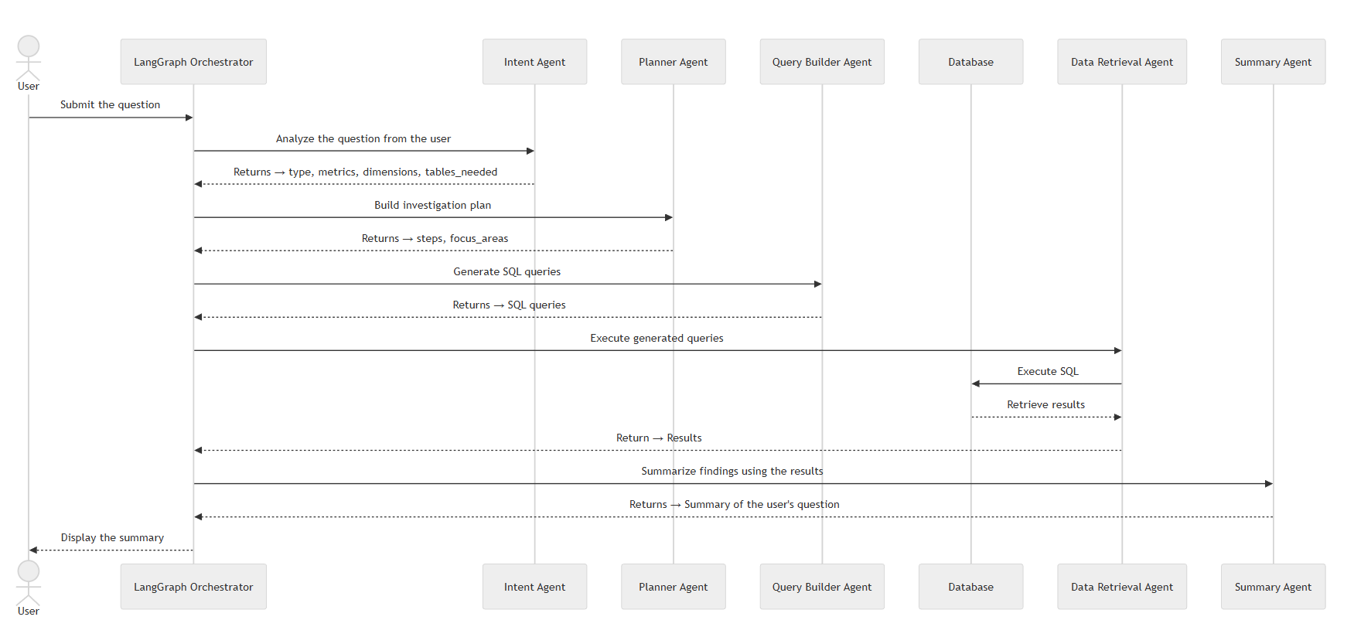
Figure: End to end agent interaction flow
    - State Evolution
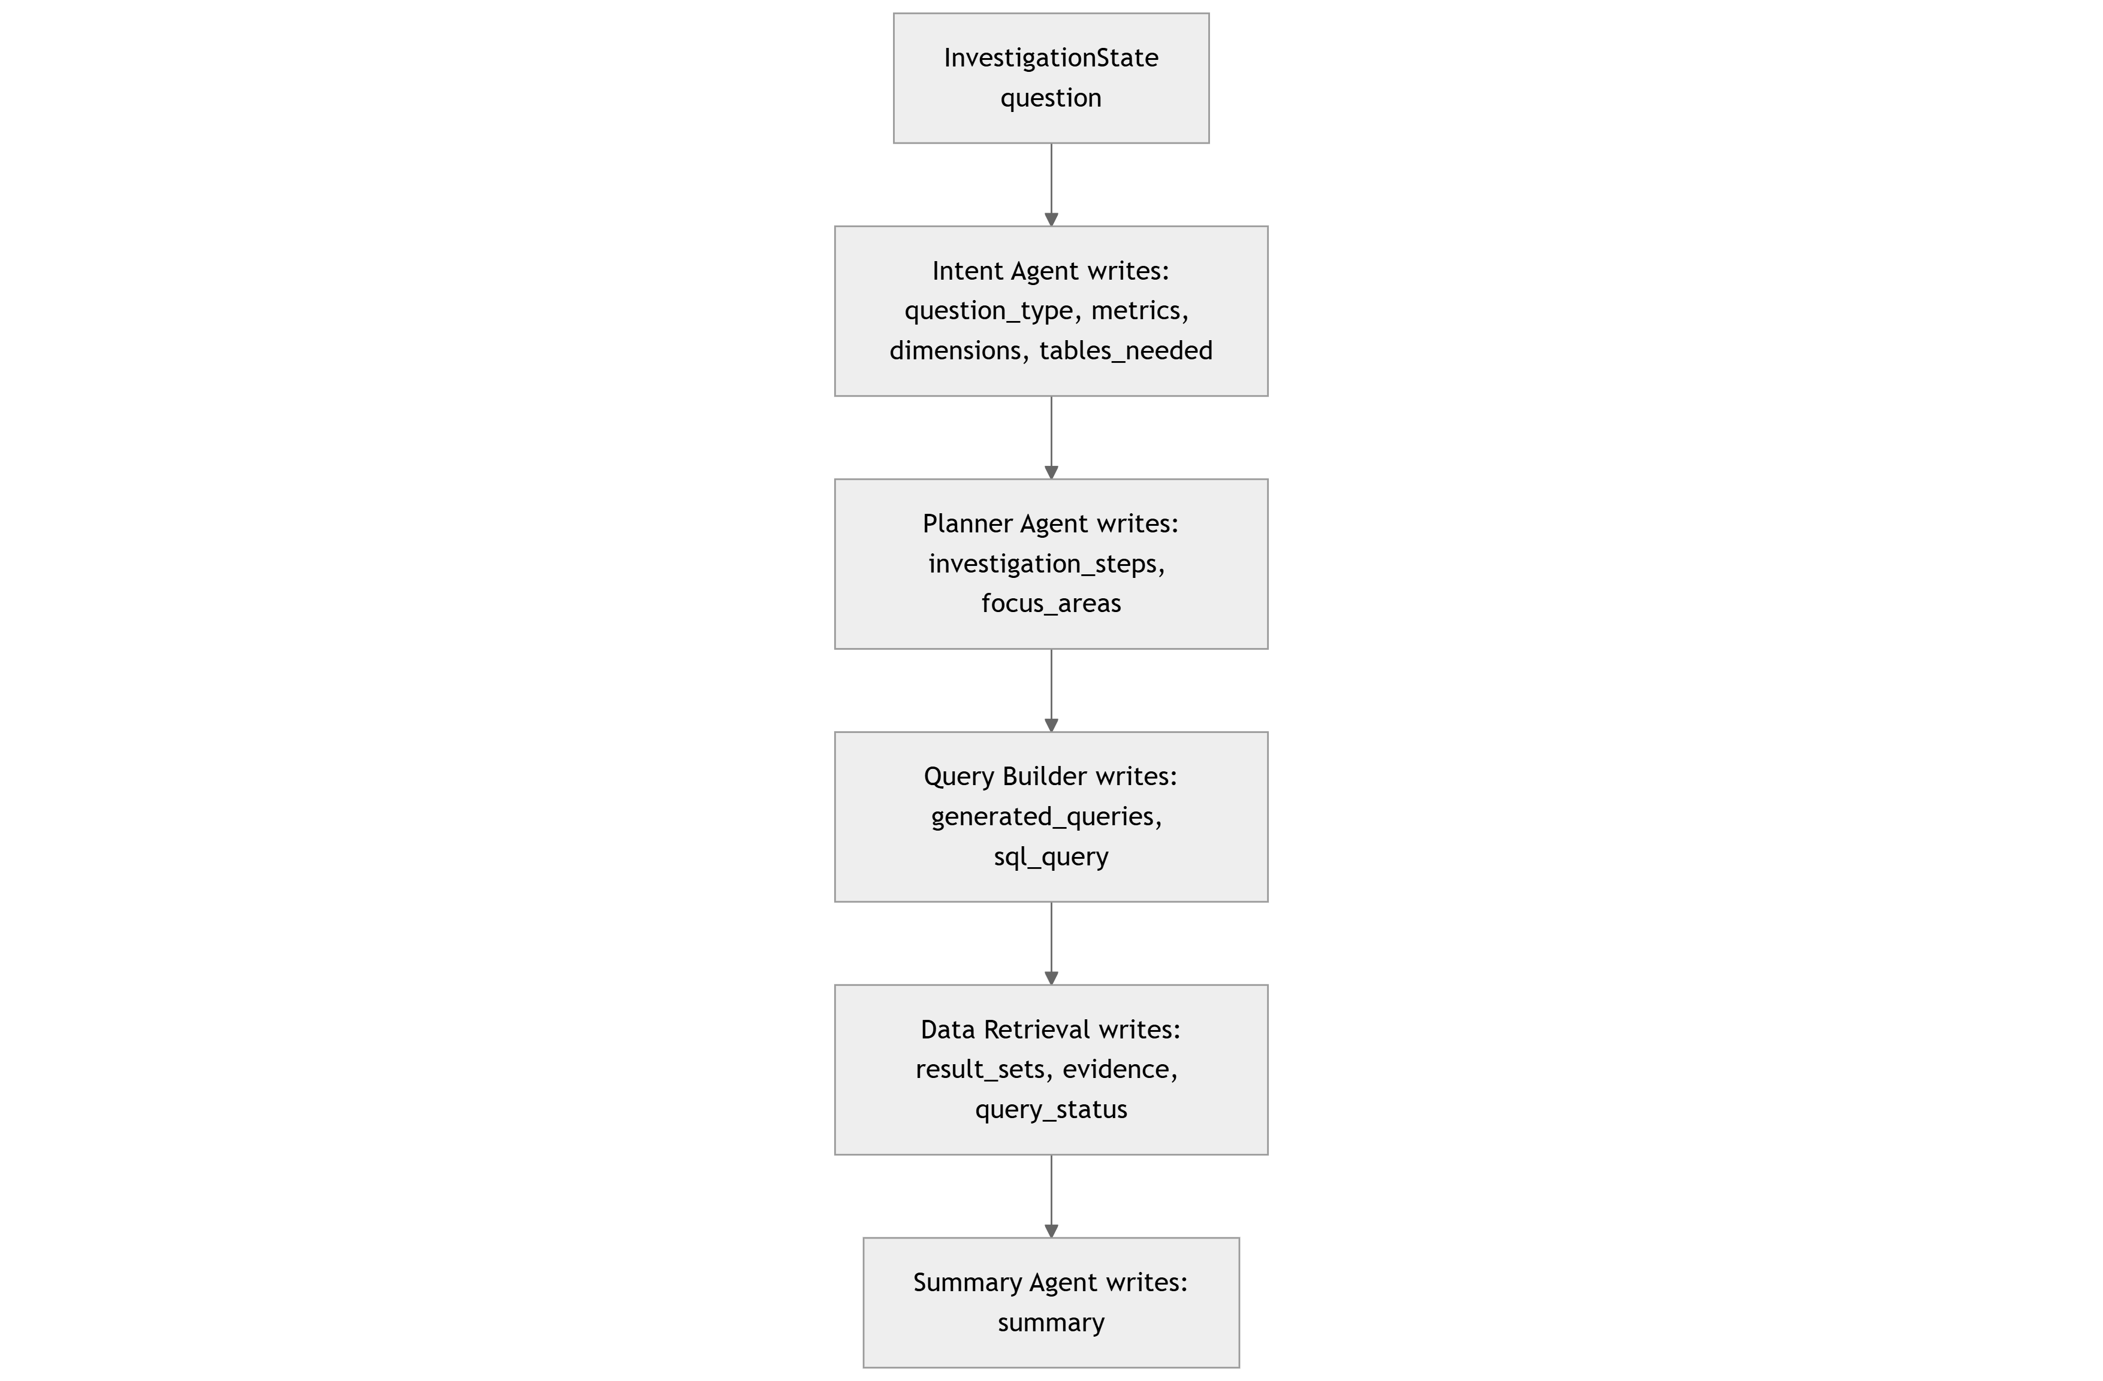
Figure: InvestigationState evolution across agents

